Introduction to Business (BUS-104-T09)
2/9/2026

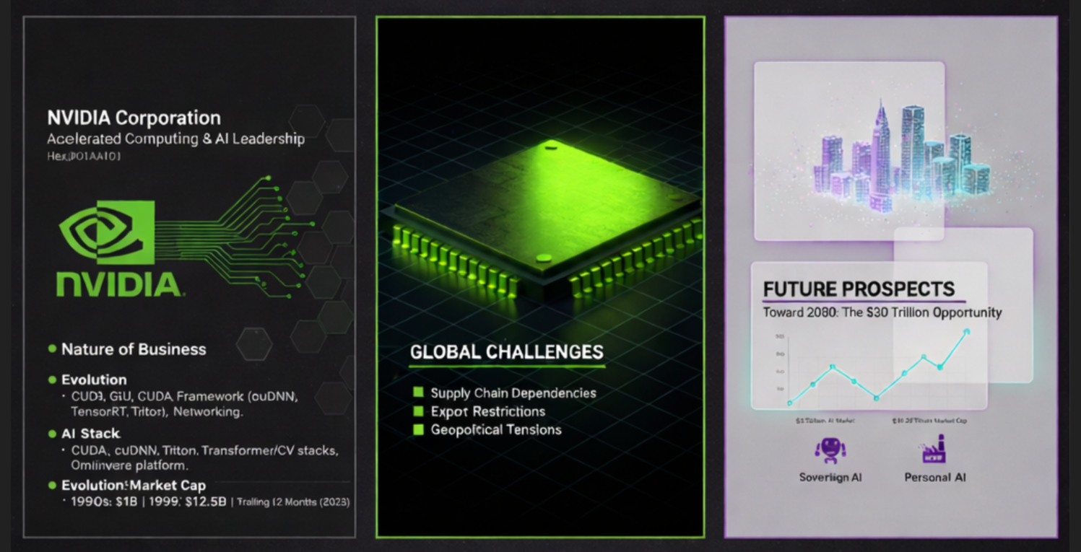

Business Information Systems (BIS)
Saskatchewan Polytechnic
Submitted for approval.
Group Members:
01. Arijit Chakma
02. Aniruddh Choudhury
03. Md Moksudul Haque
04. Md Alamgir Hossain

Submitted to:
Tariq Saleem
Instructor

Strategic Analysis of NVIDIA Corporation
Case Presentation Proposal

NVIDIA Corporation
Business Entity: NVIDIA Corporation (NASDAQ: NVDA)
Industry: Semiconductors, Artificial Intelligence (AI), and Accelerated Computing

1. Introduction
Our group has selected NVIDIA Corporation (NASDAQ: NVDA) as the subject for our business case presentation. As the global leader in accelerated computing and the primary architect of the current Artificial Intelligence (AI) era, Nvidia offers a unique opportunity to study rapid industrial scaling, competitive moats, and the complexities of global supply chain management.

2. Organization & Nature of Business
NVIDIA is a full-stack computing company based in Santa Clara, California. While historically recognized for its Graphics Processing Units (GPUs) in gaming, it has evolved into the world's most critical infrastructure provider for:
- Data Centers & AI: Powering Large Language Models (LLMs) and generative AI.
- Omniverse & Digital Twins: Creating industrial simulations for smart factories.
- Automotive & Robotics: Developing "Physical AI" for autonomous vehicles and humanoid robots.

3. Strategic Analysis Framework
Our presentation will analyze NVIDIA through the following lenses:
- Historical Evolution: The pivot from a 1993 gaming startup to the world's first company to hit a $5 trillion market capitalization in 2025.
- Global Presence: Integration into all major cloud providers and operations across 38+ countries.
- Advantages:
  - Absolute Advantage: Unmatched chip performance (Blackwell and Rubin architectures) that competitors cannot currently replicate at scale.
  - Comparative Advantage: Specialization in high-value R&D and software (CUDA), leveraging a global ecosystem for manufacturing.
- Competitive Advantage: The CUDA "Moat"—a software layer with 6 million+ developers that makes switching to rival hardware (AMD/Intel) prohibitively expensive.

4. Market Dynamics & Prospects
- Present Market (Early 2026): Nvidia currently commands over 85% of the AI accelerator market and approximately 92% of the discrete GPU market, with projected FY2026 revenues exceeding $170 billion.
- Global Challenges: We will address the risks of U.S.-China export restrictions, the transition toward custom silicon (ASICs) by customers like Google and Amazon, and the growing energy/infrastructure limits of AI data centers.
- Future Prospects: Analysis of the "Sovereign AI" movement (nations building their own AI infrastructure) and the expansion into Physical AI, with market projections reaching $15 trillion by 2030.

5. Visual Theme & Methodology
To reflect Nvidia's industrial and futuristic identity, our presentation will utilize a "Blackwell Dark" theme. These aesthetic features high-contrast charcoal backgrounds, electric green data visualizations, and isometric grids to represent the scale of modern data centers.
We will derive our analysis from FY2025-2026 financial reports, industry whitepapers, and recent strategic announcements from the Vera Rubin hardware launch.

Submitted for approval.
Group Members:
--------------------------- | --------------------------- | --------------------------- | ---------------------------
Arijit Chakma | Aniruddh Choudhury | Md Moksudul Haque | Md Alamgir Hossain

Approved By:
--------------------------------------
Tariq Saleem

